**Statistics: The Science of Decisions Project Instructions**

**Background Information**

In a Stroop task, participants are presented with a list of words, with each word displayed in a color of ink. The participant’s task is to say out loud the color of the ink in which the word is printed. The task has two conditions: a congruent words condition, and an incongruent words condition. In the congruent words condition, the words being displayed are color words whose names match the colors in which they are printed: for example RED, BLUE. In the incongruent words condition, the words displayed are color words whose names do not match the colors in which they are printed: for example PURPLE, ORANGE. In each case, we measure the time it takes to name the ink colors in equally-sized lists. Each participant will go through and record a time from each condition.

**Questions For Investigation**

As a general note, be sure to keep a record of any resources that you use or refer to in the creation of your project. You will need to report your sources as part of the project submission.

1. What is our independent variable? What is our dependent variable?

*The independent variable is the congruent or incongruent information that is displayed to the participant.*

*The dependent variable is the response time.*

1. What is an appropriate set of hypotheses for this task? What kind of statistical test do you expect to perform? Justify your choices.

*µcong – Estimation of the population mean of the response times for congruent data set.*

*µincong – Estimation of the population mean of the response times for the incongruent data set.*

*Null Hypothesis*

*H0: µcong = µincong or µcong - µincong = 0*

*The null hypothesis would be that the population mean of the incongruent data would not differ significantly from the population mean of the congruent data set. (In other words, there will be no statistically significant difference in the participant’s performance between the congruent and the incongruent conditions.)*

*Alternative Hypothesis*

*Ha: µcong ≠ µincong or µcong - µincong ≠ 0*

*The alternative hypothesis would be that the population mean of the incongruent would differ significantly from the population mean of the congruent data set. In other words, the incongruent mean would be within the critical zones of the t test, indicating that there is a statistical difference in the performance if the color does not match the word (when compared to the results when the color matches the word).*

1. Report some descriptive statistics regarding this dataset. Include at least one measure of central tendency and at least one measure of variability.

|  |  |  |  |  |
| --- | --- | --- | --- | --- |
| **Data Set** | **Mean** | **Median** | **Standard Deviation** | **Standard Error** |
| Congruent | 14.05 | 14.36 | 3.56 | 1.22 |
| Incongruent | 22.02 | 21.02 | 4.78 |
| D (Incong – Cong) | 7.96 | 7.67 | 4.86 | 0.99 |

*Below is a graphical representation of each of the data sets.*

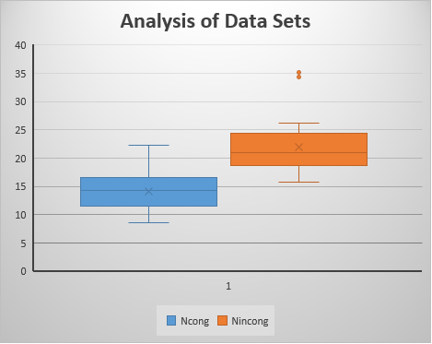

*In this box plot, you can see the median, mean and inner quartile of each sample. In addition, one can start drawing some informed assumptions about what the result of the statistical test will demonstrate. The difference in the data is stark. Not only is the inner quartile of the incongruent sample dramatically higher, one will also note that while there were no outliers in the congruent data, the incongruent data caused dome participants to drastically underperform not only their own congruent test, but the entire remainder of the sample population.*

1. Now, perform the statistical test and report your results. What is your confidence level and your critical statistic value? Do you reject the null hypothesis or fail to reject it? Come to a conclusion in terms of the experiment task. Did the results match up with your expectations?

*This experiment represents a dependent scenario as the dependent and the independent variables are performed by the same participant. Because this is a small data set and we wish to use this to draw conclusions about population estimates, we will use the dependent 2 tailed t test to evaluate. Below are the data points necessary to perform this statistical test.*

*α = 0.05 Confidence Level = 95%*

*df = 23 t = 8.021*

*tcritical = +/- 2.069 p < .0001[1]*

*Because the t statistic is in the critical zones of the distribution, the conclusion is that we should reject H0.*

*Conclusion: The response times for the experiment using incongruent information were longer by a statistically significant amount when compared to the experiment using congruent information. The probability of this variation occurring by random chance is less than 0.5%. This matches not only my intuition, but also my own personal results when participating in the experiment.*

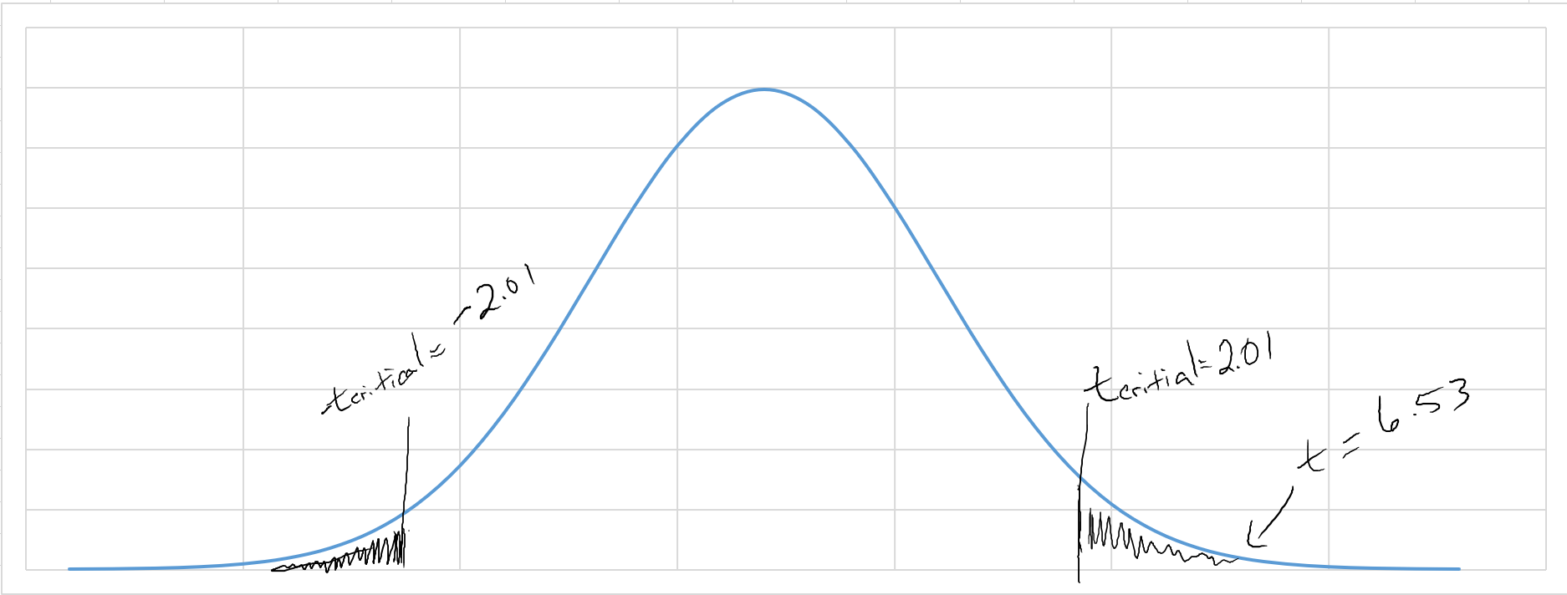

1. From GraphPad: <https://www.graphpad.com/quickcalcs/pValue2/>